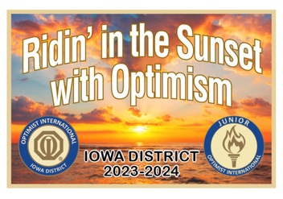
Iowa District Optimist
3rd Quarter Conference
April 19-20, 2024
Holiday Inn & Suites Des Moines - Northwest
4800 Merle Hay Road, Des Moines, IA 50322

Friday, April 19, 2024—Executive Committee (Casual District Attire)
Lt. Governor’s Dinner 5:30 p.m.
Executive Business Session 7:30 p.m.

Saturday, April 20, 2024—District Board (District Business Attire)
Registration 7:15—8:25 a.m.
PGA Meeting 7:15—8:15 a.m.
First Timer Orientation 8:00—8:25 a.m.
General Session 8:30—9:00 a.m.
Workshop Session 9:10—9:50 a.m.
Oratorical Contest/Essay Winner………………………………………………………….…….10:00—11:30a.m.
Zone Meetings 11:35—11:55 a.m.
Lunch & Awards/Quad Governors 22-23 Award Celebration 12:00—1:25 p.m.
Workshops Session/Round Tables 1:30—3:00 p.m.
Closing Session 3:05—4:00 p.m.

Lodging: Holiday Inn & Suites, 4800 Merle Hay Rd. Des Moines, IA 50322
Phone 515-278-4755 or 800-HOLIDAY (800-465-4329)
For Guaranteed Iowa District Optimist Room Rate of $95.00 (Standard) book by April 5th
Group code: OPT

Registration – Detach, Mail or Email:
Early Registration Deadline April 7, 2024, $35.00
Late Registration April 8 and after $50.00
Send To: District Sec/Treas.—Janet Lloyd, 638 8th Street, West Des Moines, IA 50265
or Email: OptimistIowaSecretary@gmail.com
Make checks payable to: IA District Optimist
This is my first-time attending a District Conference.

Optimist Name: ______________________________________________________________

Club Name: ________________________________________ Club # 40-_____ Zone ______

Email: ______________________________ Club/District offices _______________________

Special Dietary Request (ex. Vegetarian) __________________________________________
Help support the OIF Silent Auction? Check the box if you plan on bringing an item for OIF.

